Retrieving Data (Unstructured)

Rule-based resume parsing system using:
- pdfplumber → Extract raw text from PDF
- Regex → Extract structured patterns
- spaCy → Process language + identify entities

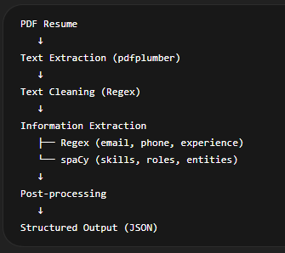

STEP 1: Input Handling (PDF File)

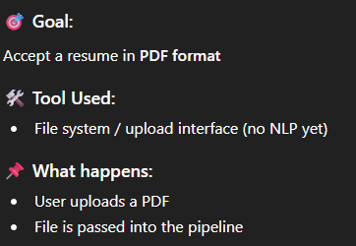

STEP 2: Text Extraction

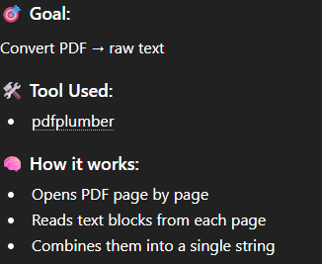

STEP 3: Text Cleaning / Preprocessing

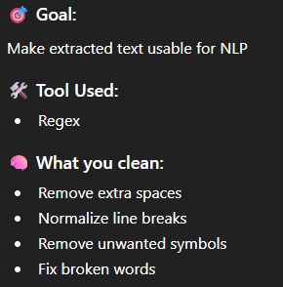

STEP 4: Basic Information Extraction (Regex Layer)

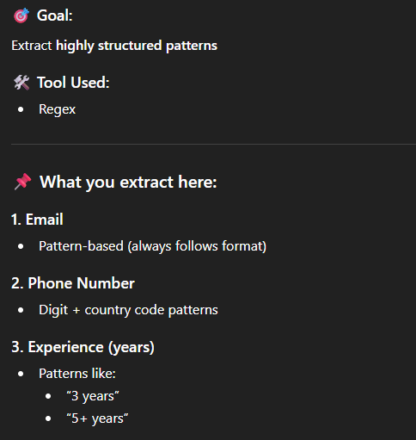

STEP 5: NLP Processing (spaCy Pipeline)

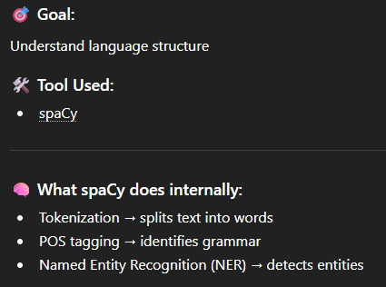

STEP 6: Skill Extraction (spaCy Matcher)

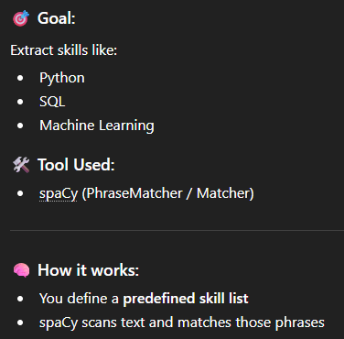

STEP 7: Entity Extraction (spaCy NER)

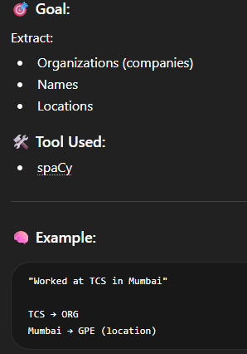

STEP 8: Rule-Based Role Detection

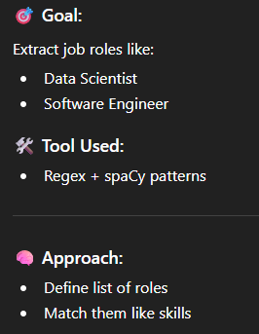

STEP 9: Post-Processing

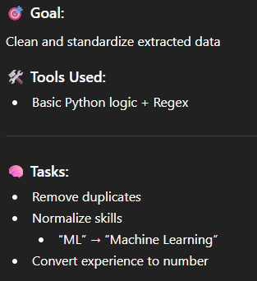

STEP 10: Structured Output (Final Result)
